GREENWOOD PUBLIC SCHOOL, ADITYAPURAM
OUR MOTTO - DEVELOPMENT WITH DELIGHT
SYLLABUS FOR THE THIRD EVALUATION 2017-18
CLASS-I
SUBJECTS | BOOKS | LESSONS |  |  | SKILLS | ACTIVITY+USE OF ICT |  | PARENTS INVOLVEMENT
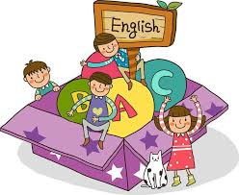  ENGLISH | New Pathways | Ch-7: The New watchman  Ch-8: Thank you  Ch-9: Bunny and His New Friends  Ch-10: Come, Let us Play! |  |  | Read, Understand, Pronunciation,  Clarity | Extra marks  Storytelling |  | Give your child regular loud reading practice.
 | Writing Skills | Application  Birthday Party Invitation Card  Paragraph on save water/ Holi |  |  |  |  |  | Encourage your child to read story books.
 | Speaking Skills | Story- The Goose with the golden eggs. |  |  | Discuss, Listen,  Concentrate,  Recall | Extra marks  Story
 | 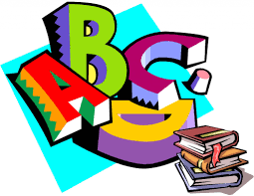  Grammar & Composition | Ch-8Action Words Ch-9 Is ,Am , Are , Has , Have Ch-10 In ,On ,Under , Near ,Behind Ch-11 Capital Letters ,Definition of Adjective /Adverb , Singular/Plural ,Gender, Opposites. |  |  | Comprehend,  Identify | Extra marks  Adjective  Adverb  Singular Plural  Opposites  Gender |  | Help your child to learn ‘describing words’ Play games based on ‘one and many’ Talk to your child in English Language Using Adjectives & Adverbs in daily sentences.
 | Group Recitation | Puppy and I, Ice Cream Fun. |  |  | Recite, Appreciate |  |  | Help your child to learn the poem.
HINDI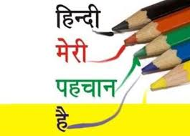 |  | ikB&17: विसर्ग का प्रयोग  ikB&18: _ की मात्रा वाले शब्द  ikB&19: रेफ की मात्रा वाले शब्द  ikB&20: र पदेन तथा आधे अक्षरों वाले शब्द ikB&24: ईमानदारी  ikB&27: अनोखा खिलौना  ikB&29: लोमड़ी की चालाकी  ikB&30: चतुर चूहा |  |  |  |  |  | ikB i<+ok,¡
 | iBu dkS'ky | vifBr x|ka'k ] i|ka'k |  |  | mPpkj.k 'kfDr c<kuk | ^vk* ls 'kq: gksus okys nl okD; fy[ksa
 | ys[ku dkS”ky | esjk fiz; fe= @ esjk ns”k Hkkjr |  |  | vfHkO;fDr Lrj
 | ekSf[kd {kerk | ¼dfork½ मेरी चाह ]बिल्ली मौसी |  |  | Lej.k 'kfDr | >aMs dk fp= cukdj mlesa jax Hkjsa |  | dfork ;kn djok,¡
 | Jo.k {kerk | ikB&28: यातायात संकेत (सामान्य ज्ञानवर्धक कथा सुनाकर प्रश्न पूछना |  |  | Lej.k 'kfDr |  |  | dgkuh lqukdj iz’u iwNsa
 | O;kdj.k | विलोम शब्द ] समानार्थी शब्द ] लिंग ] वचन ] अनेक के लिए एक शब्द ] सर्वनाम ] क्रिया ]laKk A |  |  | O;kdjf.kd Kku $ Hkkf"kd Kku | Extra marks  All Topics to be covered up |  | foykse 'kCnksa ds vFkZ crk,¡
MATHEMATICS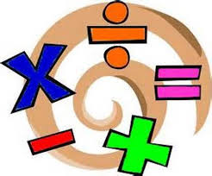 | Smart Maths |  | Ch-12: Addition  Ch-13: Multiplication  Ch-14: Subtraction Ch-15: Division Ch-16: Money  Shapes | Identify Build, Logical Thinking Decision Making |  |  | Extra marks  All Topics to be covered up | -Ask your child to distribute toffees or cookies equally among family members.  -Show your child various things of different shapes.
E.V.S. | 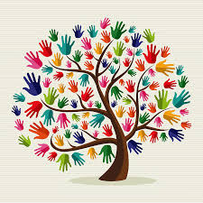  Discovering  E.V.S. |  | Ch-13:Living and Non –Living Things  Ch-14: Plants Around Us  Ch-15: Animals Around Us  Ch-16: Air and Water  G.D. – Transport | Awareness,  Critical Thinking,  And  Creative Writing, |  |  | Extra marks  Showing AV for explanation of chapters. | Talk to your child about the different modes of transport.
COMPUTER | Active Computer |  | Ch-5: Working with the mouse.  Ch-6: Drawing in Paint |  |  |  | Practical:  Chapter Based Practical’s
ART & CRAFT |  |  | Scribble Art / Origami
P.E. |  |  | Athletic Events
G.K. | Train Your Brain |  | Unit-6 General Intelligence and Reasoning , Unit-7 Sports and Entertainment
VALUE EDUCATION &  LIFE SKILLS | Pearls of Wisdom |  | Ch-8 Head Pigeon Story , Ch-9 The Queen’s Story Ch-10 Tortoise Story , Ch-11 Time of Nature |  |  |  | Tell Moral based stories to your child

