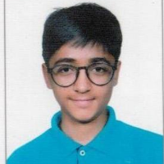
Zonal Topper
Of
national Science
UJJAWAL AGARWAL Olympiad 2019
CLASS-IX
Zonal Topper
Of
International MATHEMATICS SHREYANSH MANGAL Olympiad 2019
CLASS-IX

